7.68 Main Question (สำหรับแสดงข้อสอบ)

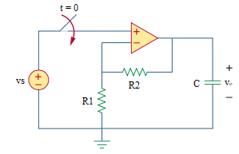

Given *vs* = 4 V, *R*1 = 10 kΩ, *R*2 = 10 kΩ, *C* = 25 µF.

Find

Variables (สำหรับเขียนโค้ดเพื่อหาคำตอบ)

Random variables

vs = {10:40};

r1 = {10000:100000:10000};

r2 = {10000:100000:10000};

c = {5e-6:50e-6:5e-6};

time = {1:10};

Global variables

# vs = 4; r1 = 10000; r2 = 10000; c = 25e-6;

vc0 = vcinf = 8;

tau = r2*c;

Part (กรอกคำตอบ)

1. vc(0-) = vc0 = 8 V

2. vc(0+) = vc0 = 8 V

3. vc(inf) = vcinf = 8 V

4. τ = tau = 0.25 s

At t>0

5. vc(t) = vcinf +(vc0- vcinf)*exp(-t/tau) = 8 V

7.70 Main Question (สำหรับแสดงข้อสอบ)

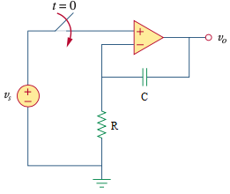

Given *vs* = 20 mV, *R* = 20 kΩ, *C* = 5 µF.

Find

Variables (สำหรับเขียนโค้ดเพื่อหาคำตอบ)

Random variables

vs = {10:40};

r = {10000:100000:10000};

c = {5e-6:50e-6:5e-6};

time = {1:10};

Global variables

vs = 20e-3; r = 20000; c = 5e-6;

vc0 = 0;

tau = r*c;

vcinf = (-t*vs)/(r*c);

Part (กรอกคำตอบ)

1. vc(0-) = vc0 = 0 V

2. vc(0+) = vc0 = 0 V

3. vc(inf) = vcinf = -200t*e-3 V

4. τ = tau = 0.1 s

At t>0

5. vc(t) = vcinf +(vc0-vcinf)*exp(-t/tau) = -200t*e-3+200t*e-3*exp(-t/0.1) V

6. vo = vs – vcinf = 20e-3+200te-3 V

7.73 Main Question (สำหรับแสดงข้อสอบ)

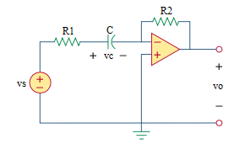

Given *vs* = 4u(t), *R1* = 10 kΩ, *R2* = 20 kΩ, *C* = 20 µF, *vc*(0) = 1 V.

Find

Variables (สำหรับเขียนโค้ดเพื่อหาคำตอบ)

Random variables

r1 = {10000:100000:10000};

r2 = {10000:100000:10000};

c = {5e-6:50e-6:5e-6};

Global variables

# vs = 4u(t); r1 = 10000; r2 = 20000; c = 20e-6; vc0 = 1;

vc0 = 1;

vcinf = 4;

tau = r1*c;

Part (กรอกคำตอบ)

1. vc(0-) = vc0 = 1 V

2. vc(0+) = vc0 = 1 V

3. vc(inf) = vcinf = 4 V

4. τ = tau = 0.2 s

At t>0

5. vc(t) = vcinf +(vc0- vcinf)*exp(-t/tau) = 4-3*exp(-5t) V

6. vo = -r2*c*(-1/tau)* (vc0- vcinf)*exp(-t/tau) = -6exp(-5t) V

7.74 Main Question (สำหรับแสดงข้อสอบ)

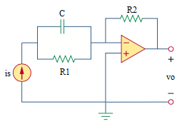

Given *is* = 10 µA, *R1* = 50 kΩ, *R2* = 10 kΩ, *C* = 2 µF, *vc*(0) = 0 V.

Find

Variables (สำหรับเขียนโค้ดเพื่อหาคำตอบ)

Random variables

r1 = {10000:100000:10000};

r2 = {10000:100000:10000};

c = {5e-6:50e-6:5e-6};

Global variables

# is= 10e-6; r1 = 50000; r2 = 10000; c= 2e-6;

vc0 = 0 V;

vcinf = is*r1;

tau = r1*c;

Part (กรอกคำตอบ)

1. vc(0-) = vc0 = 0 V

2. vc(0+) = vc0 = 0 V

3. vc(inf) = vcinf = 0.5 V

4. τ = tau = 0.1 s

At t>0

5. vc(t) = vcinf +(vc0- vcinf)*exp(-t/tau) = 0.5-0.5*exp(-t/0.1) V

6. vo = -is*r2 = -0.1 V

7.75 Main Question (สำหรับแสดงข้อสอบ)

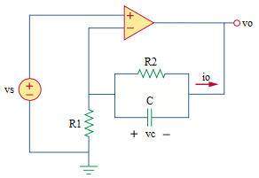

Given *vs* = 4u(t) V, *R1* = 20 kΩ, *R2* = 100 kΩ, *C* = 2 µF, *vc*(0) = 1 V.

Find

Variables (สำหรับเขียนโค้ดเพื่อหาคำตอบ)

Random variables

r1 = {10000:100000:10000};

r2 = {10000:100000:10000};

c = {5e-6:50e-6:5e-6};

Global variables

# vs= 4; r1 = 20000; r2 = 100000; c= 2e-6;

vc0 = 0;

vcinf = (-r2/r1)*vs;

tau = r2*c;

Part (กรอกคำตอบ)

1. vc(0-) = vc0 = 1 V

2. vc(0+) = vc0 = 1 V

3. vc(inf) = vcinf = -2 V

4. τ = tau = 1/50 s

At t>0

5. vc(t) = vcinf +(vc0- vcinf)*exp(-t/tau) = -2+3*exp(-50t) V

6. vo = vs-(vcinf +(vc0- vcinf)*exp(-t/tau)) = 6-3*exp(-50t)*u(t) V